

**Software Requirements Specification**

**for**

<”SpaceX” Company Management System>

**Version 1.0 approved**

**Prepared by:**

**MUHAMMAD AYAZ HASAN [20K-1044]**

**MUHAMMAD FERDEEN BAKHT [20K-0219]**

**SYED ARSALAN MUNIR [20K-1718]**

**____________________________________________________________**

**<Fast National University Of Computer and Emerging Science>**

**<date created: 19/12/2021>**

**Table of Contents**

**Table of Contents ii**

**Revision History ii**

**1. Introduction 1**

1.1 Purpose 1

1.2 Document Conventions 1

1.3 Intended Audience and Reading Suggestions 1

1.4 Product Scope 1

1.5 References 1

**2. Overall Description 2**

2.1 Product Perspective 2

2.2 Product Functions 2

2.3 User Classes and Characteristics 2

2.4 Operating Environment 2

2.5 Design and Implementation Constraints 2

2.6 User Documentation 2

2.7 Assumptions and Dependencies 3

**3. External Interface Requirements 3**

3.1 User Interfaces 3

3.2 Hardware Interfaces 3

3.3 Software Interfaces 3

3.4 Communications Interfaces 3

**4. System Features 4**

4.1 System Feature 1 4

4.2 System Feature 2 (and so on) 4

**5. Other Nonfunctional Requirements 4**

5.1 Performance Requirements 4

5.2 Safety Requirements 5

5.3 Security Requirements 5

5.4 Software Quality Attributes 5

5.5 Business Rules 5

**6. Other Requirements 5**

**Appendix A: Glossary 5**

**Appendix B: Analysis Models 5**

**Appendix C: To Be Determined List 6**

**Revision History**

| **Name** | **Date** | **Reason For Changes** | **Version** |
| --- | --- | --- | --- |
|  |  |  |  |

# **Introduction**

## **Purpose**

“SpaceX” company management system is specially designed for the Balance inquiry for space projects .This product provides the different financial record which is applied to implement the different project.It is specially made for the users who want to manage the activity of the company like managers,Financial agents,Entrepreneurs.

## **Document Conventions**

Convention for Info page:

* Font Face :Normal
* Font style:Bold
* Font Size:20dp

Convention for Project Pages:

* Font Face :Normal
* Font style:Normal
* Font Size:20dp

## **Intended Audience and Reading Suggestions**

Different type of readers and users include:

i)Manager

manager firstly login his/her account and then see his personal information like name,id,date of appointment and his current status.Manager also manage the different transactions of financial amount on different projects .

ii)Public user

If you are a new user you can also use this product and you have to login as a guest and then you can understand about the system like what is the purpose of this system ,What different functions this system manages.

iii)Developers

Developers are the frequent active users of this system because they have to implement every single change in the system or any update in the system.They also manage the UI of the system.

## **Product Scope**

System provides secure registration account information for the users.

This system automates the different financial inquiry process.It handles all the investing amount of project owners, different amount transactions between them,watch and calculates all the revenue and budgets generated from these projects.System also provides the information of active employees like managers .

This project can easily be implemented in different circumstances .New features can be implemented according to requirement,reusability and flexibility possible in different modules.

## **References**

**SpaceX user’s_guide:**<https://www.spacex.com/media/falcon_users_guide_042020.pdf>

**Java Guidance:**<https://www.w3schools.com/java/default.asp>

# **Overall Description**

## **Product Perspective**

SpaceX is “Space Exploration Technologies Corporation '',an American aerospace company founded in 2002 by Elon Musk .It is the first company that successfully launched the spacecraft and returned it from earth orbit.

This product is a follow on member of a real product.This product just defines the financial activities of the aerospace projects and handles the employee information.Updating data is difficult as well due to the data being on manual terms.Therefore,this system come with the following features in hopes of revolutionizing the company management This product is the sub-section of the large project which handle the account management of the projects and control all the balance inquiry.

Making the system automated through our computerized system. Chances of errors are less due to machine’s involvement meanwhile updating data will also be easier through our system. No meddling will be there because every user will be provided by his ID in order to access the system.

## **Product Functions**

Following are the functions which is performed by the system:

* System must accept the valid email address and password in order to login to the system.
* System must provide the personal info of the user.
* System provides the menu type option for accessing the different projects.
* System must calculate the balance inquiry of each project.

Following are the functions which is performed by the user:

* In order to access the system the user must have to provide a valid email address and password otherwise the system rejects the user.
* Only current users manage the project info; guest users cannot access the project section without creating an account.
* In order to check the balance inquiry of the project, users must have to provide every single element of the trial balance like asset,liabilities, revenue,capital.

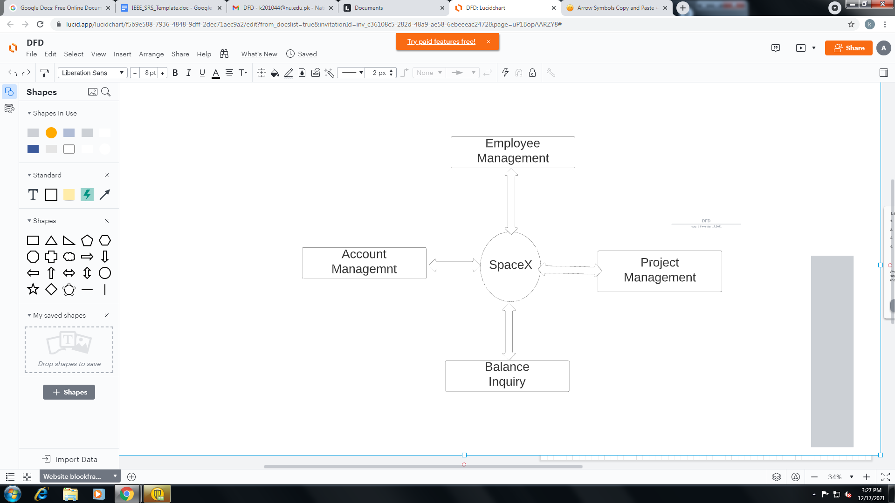

## **User Classes and Characteristics**

**BASIC EDUCATIONAL TYPE:**

Users should be comfortable with the English language in order to better access to the system.

**TECHNICAL EXPERTISE:**

Users should be familiar with general daily life applications of accounting and finance and should have a slight know how of it.

This system provides different services based on the user's type.

Features that are available to the manager are:

* He can view his personal details
* He can view the projects that are under progress
* He can control the balance inquiry of each project

Guest users can only view the information of the System .

## **Operating Environment**

This product operates in Android operating system.”SpaceX”Company management system is a mobile application and shall work in all Android based Environment.No Internet is required to run this application.

The Hardware Configuration including CPU:1.3GHzDual_core or above. RAM:512MB minimum.4GB built-in memory. Only support TouchPad Devices.

## **Design and Implementation Constraints**

* All the information of the user,company,and projects must be stored in files that are accessible by the system.
* Android Studio IDEA is used to design and implement the system
* Java language is used to implement the system.
* The SpaceX company management system is running 24 hours a day.
* Users may access the system from any mobile device which has an android operating system.

## **User Documentation**

**Falcon 9 user’s manual :**<https://www.spaceflightnow.com/falcon9/001/f9guide.pdf>

**Mission Mars user’s guide:**<https://www.spacex.com/human-spaceflight/mars/>

**Falcon Heavy/Dragon tutorials:**

<http://www.axmpaperspacescalemodels.com/old/files/Falcon9instructionmanual.pdf>

## **Assumptions and Dependencies**

The assumptions are as:

* The Code must be error free
* System should must be user friendly and easy to understand for new user
* All the invest amount,generate revenue,account transactions must be saved in the file so it can be accessible at any time.
* System should support all types of amount transactions in trial balance.
* The system must be available 24/7 for balance inquiry
* Users must have to provide a valid username and password to enter the account and perform actions.

The dependencies are as:

* The certain software and hardware due to which the system will be run.
* The system developed on the basis of all the specifications and listing all the requirements.
* The end user(Manager) must have proper knowledge about finance to use the system.
* Users must have an Android Operating system based device in order to use this system.

# **External Interface Requirements**

## **User Interfaces**

This software provides a friendly user interface for the new users and the manager can easily operate the system and perform their desired tasks like updating, viewing the details of the projects that are under progress.

**GUI Standards:**

**3.1.1 Visibility of System:**

Users, especially managers, always get information about every detail of the projects and easily understand the process of balance inquiry and see every info on a clear screen in a reasonable time.

**3.1.2 Consistency:**  
Both the Graphical element and different terminology are similar across the system.Copy and print icon is implemented in order to copy and print the information stored in the system.

**3.1.3 Login Interface:**

In order to enter in the system user must have to provide valid username and password if he did not provide any required information system must show the error message “Name/Password cannot be left empty”

**3.1.4 Categories View:**

System shows the different projects in a listed view so that every project can be easily and separately accessible.

**3.1.5 Trial Balance Interface:**

This interface support all the calculating of data like assets ,liabilities,Revenues which is enter by the user

## **Hardware Interfaces**

This application supports Android,IOS mobile devices.No other Hardware required.

## **Software Interfaces**

Since It is a mobile application,it needs only devices which have Android version 4.0 or higher to run this application.

## **Communications Interfaces**

This application is used to communicate with all android devices.Wifi-Direct communication is not supported in android platform.It is just an ordinary level application for managing the balance inquiry of the company projects.

# **System Features**

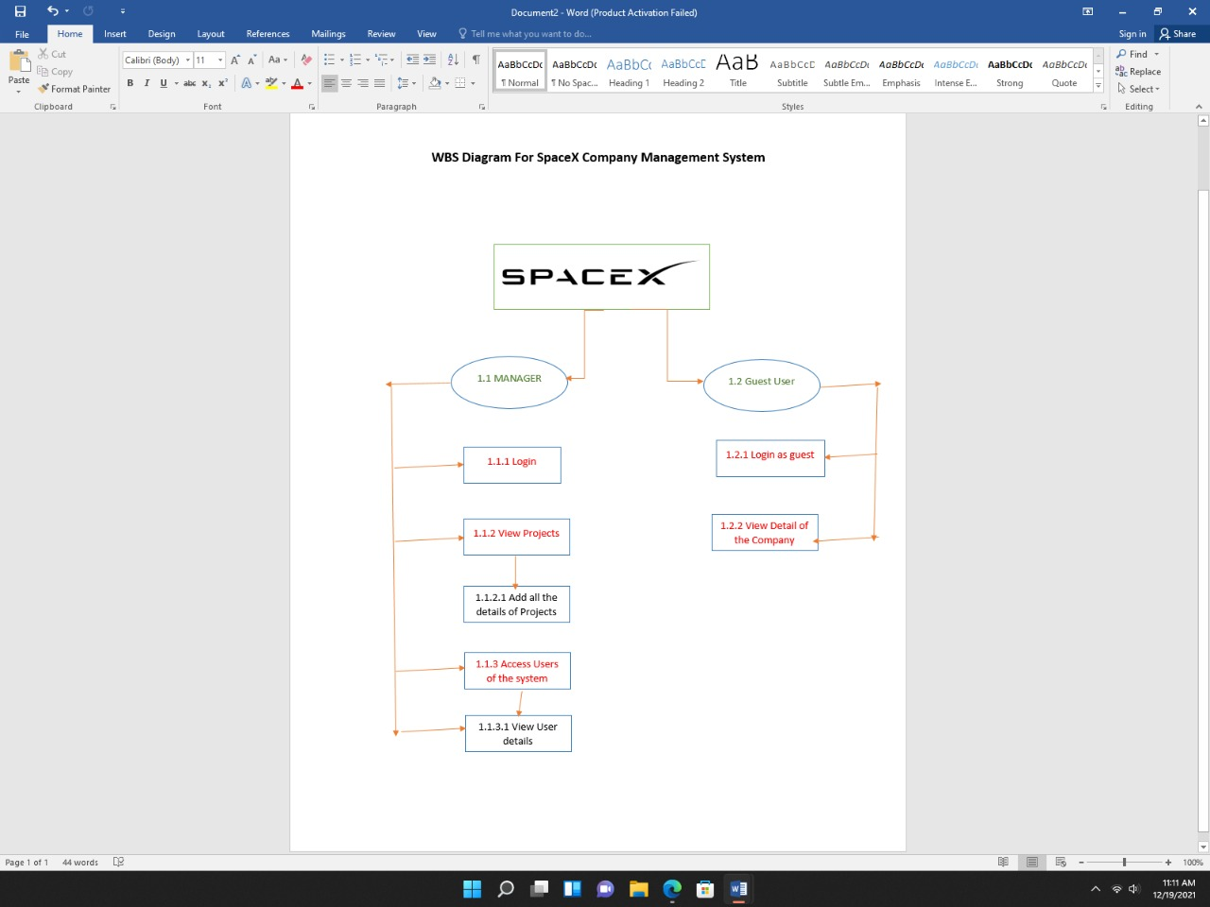

## Login Feature

**4.1.1 Description and Priority**

This feature is implemented in order to maintain the safety and security for the data present in the system. Priority of this feature is High

**4.1.2 Stimulus/Response Sequences**

* User enter username and password
* If the username and password is missing, the system shows the message”Name/Password cannot be left empty”.
* If username and password is valid system take the user to the home page

**4.1.3 Functional Requirements**

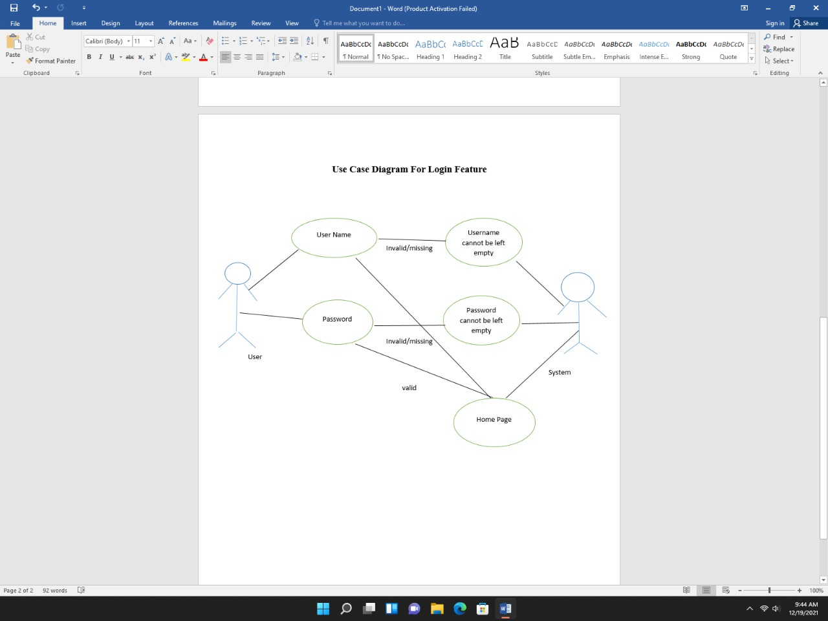

## Balance Inquiry **Feature 2**

**4.2.1 Description and Priority**

This feature is implemented in order to calculate all the amounts spent on the projects, all the transactions of amount and all the revenues which are generated from the project.Priority of this feature is high.

**4.2.2 Stimulus/Response Sequences**

* users enter all the elements in a balance sheet.
* System check weather the maximum element limit is <=5
* If elements exceed its limit system shows the message “Assets cannot be greater than 5
* If valid data is provided, the system should calculate and display the trial balance of the desired project .

**4.2.3 Functional Requirements**

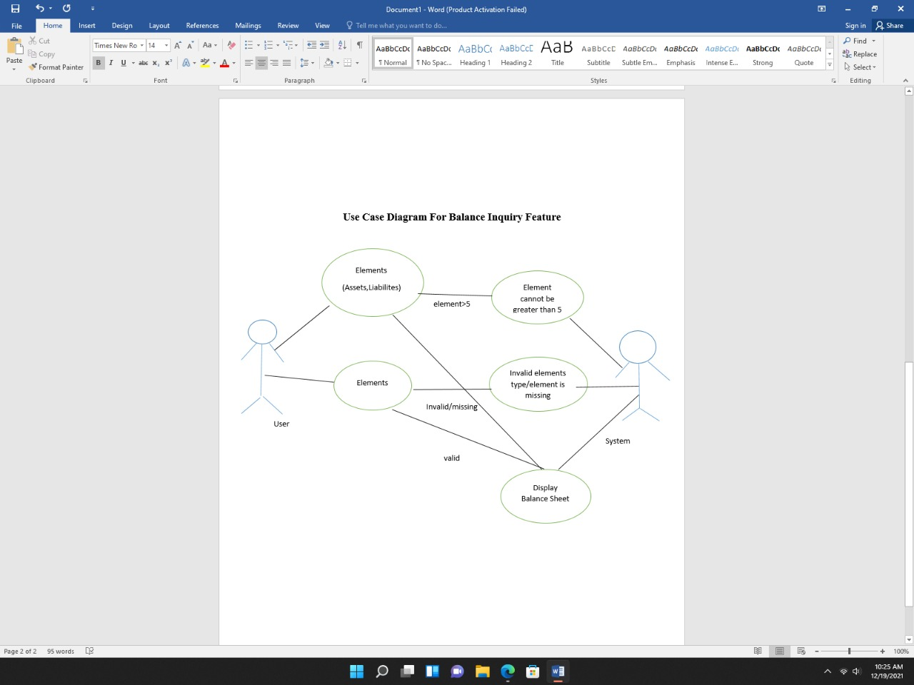

# **Other Nonfunctional Requirements**

## **Performance Requirements**

* **User Satisfaction*:*** The system will stand up to the expectations of the user.
* **Error Management*:*** Responses to errors have been given so that the system doesn’t lag behind in the case of an error.
* **User Friendly:** The system is easy to use having a very friendly GUI.
* **Response Time:**The system has optimal response time to all types of queries through some efficient programming.
* **Robustness*:*** The system is robust as it protects your safety and safeguards against unwanted events.

## **Safety Requirements**

File may get deleted or crashed due to viruses in the system or operating system requirement.Therefore,the recovery method “Backup file” is required to save all the data in any uncertain cases.

## **Security Requirements**

### The system uses login signup with an authentic account so that no third user can access it making the data confidential and secure. Moreover, if credit card payments are made then they are also done through secure methods to avoid the risk of any loss. Moreover, passwords are also kept secured to remove the possibility of them falling in the wrong hands.

## **Software Quality Attributes**

**Availability:**

The system should be available at any time as managers want a frequent result of the balance inquiry.

**Correctness:**

The System must provide the correct calculation of the enter data,otherwise all the balance will be dissmatch.

**Maintainability:**

The manager who is in charge should be able to maintain the order of data entered in order to get a satisfactory result.

**Usability:**

The system must be able to satisfy the maximum number of elements entered by the user.

## **Business Rules**

The software system must provide the administrator account manager function.

Minimum user account types should be: (1)Manager (2) Administrator.

The Account Manager type will grant access to the user for the final purpose and data management on file. Administrator account type will provide "super user ”access to the user for the purpose of managing the software system. Managers the function of the software system is of paramount importance.

# **Other Requirements**

Active users of the system are Managers of different departments.They are assumed to have basic knowledge of Account and Finance in order to enter the data and calculate the Trial balance for different projects.

**Appendix A: Glossary**

**GUI:** Graphical user interface

**SpaceX**:Space Exploration Technologies Corporation

**OS:**Android Operating System

**Appendix B: Analysis Models**

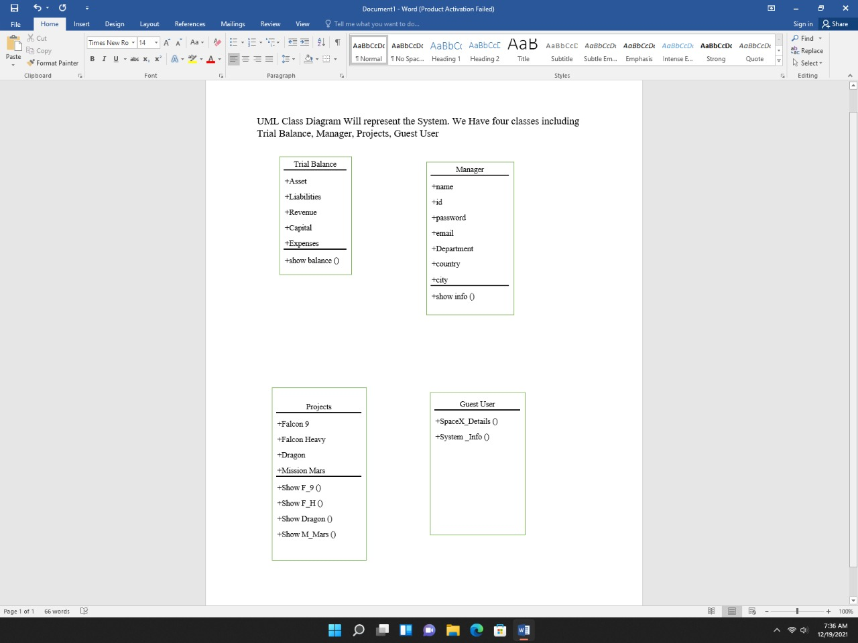

**Appendix C: To Be Determined List**

[**https://www.google.com/**](https://www.google.com/)

[**https://www.ieee.org/conferences/publishing/templates.html**](https://www.ieee.org/conferences/publishing/templates.html)